FTP
Filezilla
Sftp://ftp.pcracknell.tafewest.com
Username (the one from Cpanel) pcracknell
Password (the one from Cpanel)
Port 22 21?
Then quickconnect
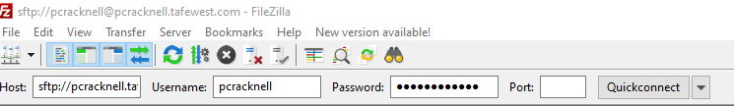

Remember not to use any capital letters or spaced in any files names or things will not work
Create a folder in you “Documents” folder called eg HTML zip your files
Move your files (resources and images to this folder)
Drag and drop from the bottom left panel to the right – never back the other way
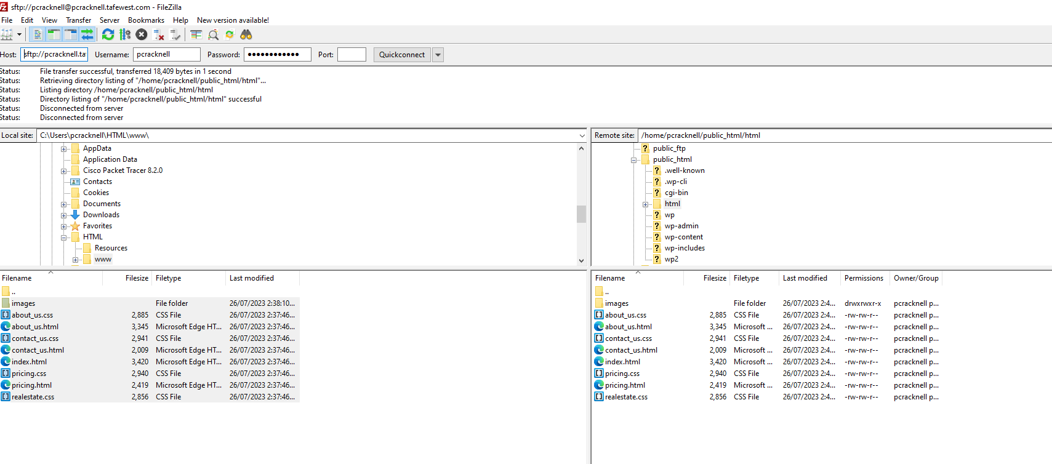
URL will be:

pcracknell.tafewest.com/html

html being the name of the folder that is saved the site in on my harddrive.

