Assessment 2 of 2: Project

Criteria

Unit code and name
ICTWEB431 | Create and style simple markup language documents

Qualification/Course code and name
Select your Qualification/Course code and name from the dropdown.
Code | Course name

Student details

Student number
900045663

Student name
Jake woolley

Assessment declaration
Note: If you are an online student, you will be required to complete this declaration on the TAFE NSW online learning platform when you upload your assessment.
This assessment is my original work and has not been:
- plagiarised or copied from any source without providing due acknowledgement.
- written for me by any other person except where such collaboration has been authorised by the Teacher/Assessor concerned.

Student signature and date
Jake woolley 26/5/2026

Version: 20240109
Date created: 2 August 2018
© 2021 TAFE NSW
RTO Provider Number 90003 | CRICOS Provider Code: 00591E
This assessment can be found in the: Learning Bank
The contents in this document is copyright © TAFE NSW 2021 and should not be reproduced without the permission of TAFE NSW. Information contained in this document is correct at the time of printing: 3 June 2026. For current information please refer to our website or your Teacher/Assessor as appropriate.

Assessment instructions
Table 1 Assessment instructions
Assessment details | Instructions
Assessment overview | The objective of this assessment is to assess your knowledge and performance to design and create basic markup language documents and cascading style sheets (CSS).
Assessment event number | 2 of 2
Instructions for this assessment | This is a project-based assessment that assesses your knowledge and performance of the unit.  This assessment is in six parts:  - Review client requirements  - Identify and refine client requirements  - Create and style the website  - Test and validate the website  - Hand over website  - Correct an error  And is supported by:  - Assessment checklist  - Observation Checklist 1  - Observation Checklist 2  - Assessment feedback  - Supporting documents  Note: This assessment may contain links to external resources. If a link does not work, copy and paste the URL directly into your browser.
Submission instructions | On completion of this assessment, you are required to submit it to your Teacher/Assessor for marking. Where possible, submission and upload of all required assessment files should be via the TAFE NSW online learning platform.  It is important that you keep a copy of all electronic and hardcopy assessments submitted to TAFE and complete the assessment declaration when submitting the assessment.
What do I need to do to achieve a satisfactory result? | To achieve a satisfactory result for this assessment you must answer all the questions correctly.  If a resit is required to achieve a satisfactory result it will be conducted at an agreed time after a suitable revision period.
What do I need to provide? | - TAFE NSW student account username and password.  - Computer or any other device with internet access  - Text editor/s software e.g., Notepad, Sublime, Atom (No auto generating software e.g., Dreamweaver)  - Access to common web browsers.
What the Teacher/Assessor will provide | - Access to the learning management system.  - Scenario documents as outlined in assessment:  - Client resource folder (ICTWEB431_AE_Pro_2of2_SR1.zip)  - Website folder with error (ICTWEB431_AE_Pro_2of2_SR2.zip)
Due date  Time allowed  Location | Please refer to UAG for this unit or your individual Training Plan  - Part 1: One hour  - Part 2: 15 mins  - Part 3: Two hours  - Part 4: 30 mins  - Part 5: 15 mins  - Part 6: 30 mins
Assessment feedback, review or appeals | In accordance with the TAFE NSW policy Manage Assessment Appeals, all students have the right to appeal an assessment decision in relation to how the assessment was conducted and the outcome of the assessment. Appeals must be lodged within 14 working days of the formal notification of the result of the assessment.  If you would like to request a review of your results or if you have any concerns about your results, contact your Teacher/Assessor or Head Teacher. If they are unavailable, contact the Student Administration Officer.  Contact your Head Teacher/Assessor for the assessment appeals procedures at your college/campus.

Specific task instructions
The assessor will use the criteria outlined in the following tasks to determine if you have satisfactorily completed this assessment event. Follow these instructions to ensure you demonstrate the required knowledge and skills.

Scenario
Sorrento by the Sea is a new real estate agency specialising in luxury apartments located on the picturesque Mornington Peninsula. They have contacted a web designer to build their website. They want to promote their apartments and help increase occupation of rental residencies during the off-season. They need this job completed at the end of four weeks.
The new agency owners would like to highlight unique attractions of the area, such as the calm front beach on Port Phillip Bay and the wilder surfing beaches on the Bass Strait side, coastal walks, swimming with dolphins and fishing. These cater for all ages and tastes.
The website must have a contact page with a map (this can be a screenshot image) and contact number. They want to focus on the ease of access for nearby Melbourne residents and have provided an enticing pricing structure for people who want to get away from the city for a few days. They also want to highlight the pet-friendly policy of this apartment.
Students must download and unzip the resource folder (ICTWEB431_AE_Pro_2of1_SR1.zip) from the client. It contains images of the apartment and the local features, some general information about the business, unit and area, a logo, and icons.
They would like a two-column layout that prints appropriately (i.e., include print styles). Styles and colours to include in the site are listed in the technical specifications below.
Table 2 Technical specifications
Feature | Associated style
Global font hierarchy | Helvetica, Calibri, suitable default
Primary navigation links | #4d1d18, remove default underline
Navigation hover effect | #555
Major heading | #87423c, 36 pixels
Sub-headings | #4d1d18, 24 pixels
Paragraph text | 150% line height
Content links | #87423c
Footer text and links | #87423c

Part 1: Review client requirements
You must review the client requirements in the scenario. Based on the review, you must complete the following tasks and record the information in a word-processed document. They should use specialised and technical language and diagrams where appropriate.
- Create an appropriately sequenced schedule of the activities you need to complete for this project, according to the client’s timeframe (this can be in a table). This must include specific tasks for designing, developing, and implementing the website.
Table 3 Schedule
Step | Activity | Schedule
1 | Review and understand the client requirements | 3 days
2 | Creating wireframes and sitemap | 2 days
3 | Submitting for the client proposed looks in wireframe and sitemap form | 2 days
4 | After getting acceptance work toward building the basic info in html | 5 days
5 | Work on improving info and making sure with the client you have the correct amount of info | 1 day
6 | Start to style the CSS toward what the client likes | 5 days
7 | Test and validate the website in multiple browsers and correct errors | 2 days
8 | Preform more tests to make sure it’s all working | 1 day
9 | Bring the current build to the client and ask for any changes | 1 day
10 | Change as required and prepare the final build for more testing | 2 days
11 | Present the finished product to the client and if needed handle and problems caused or changes needed | 2 days
12 | Final round of bug fixing | 1 day
13 | Launch | 1 day
13 | Celebrate or lament | Same day^

Determine what pages are required for the website and build a suitable sitemap.
-home page, contact page. Also needed are a pricing/preview page and a highlight page for nearby attractions
home

highlights
pricing
Contact us (w/map)

- Design and build wireframes that depict the structure for the Home and Contact pages.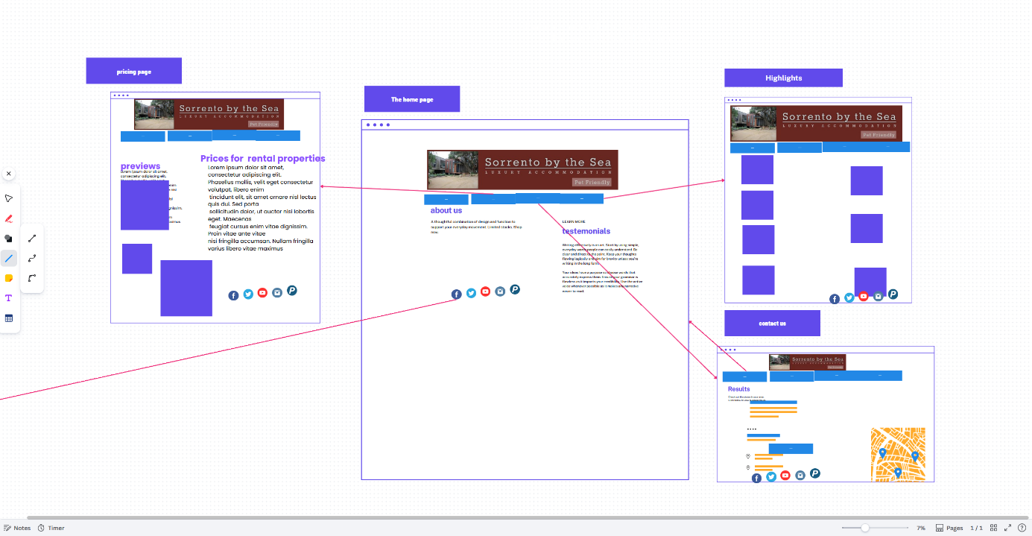
- You should develop a testing approach to be used for testing the finished website, including appropriate test cases and a testing checklist. -Checking with w3c validator as well as checking to see if it loads correctly in at least 3 browsers including chrome which is more popular nowadays
- You should select the most appropriate mark-up language to meet all the requirements for the site and discuss why this is the best choice in Part 2. Html and CSS together should make this website easy to create and style to the clients’ needs

Part 2: Identify and refine client requirements
To complete this part of the assessment, you will participate in a roleplay to demonstrate your ability to complete skills-based tasks to industry standards. The role play will be digitally recorded via video or voice recording and submitted as evidence.
Your demonstration will be used as part of the overall evidence requirements of the unit.
You should refer to the list of criteria provided in the Observation Checklist 1 to understand what skills you need to demonstrate in this section of the assessment. This Checklist outlines the assessment criteria your Teacher/Assessor will be marking you on.
Roleplay
The next step is to meet with the client in a role play of 10-15 minutes to identify the work outcomes and clarify the requirements for their website project.
Role of the student being assessed
You will participate in a role play, playing the role of web developer. You need to include the following:
- Identify the work outcomes that you need to fulfil by discussing the client’s requirements from the scenario (including the organisational standards), as well as determining any further requirements they may have.
- Discuss and confirm your role and responsibilities as a web designer within this website project.
- Review and discuss the wireframes and sitemap (from Part 1) and determine whether any further refinements need to be made.
- Review and discuss the testing approach and test cases (from Part 1) and determine whether any further refinements need to be made.
During the roleplay, you must demonstrate the following skills:
open-ended questioning and active listening, including paraphrasing and summarising
clear and detailed language.

Role/s of the person/s in supporting roles
Ask a colleague, or another student to act in the supporting roles. Make sure each person has the following instructions to work from.
This role play will require the following roles:
- Client
The student needs to greet you first, and respond appropriately (e.g., shake hands). The student undertaking the role of the website developer needs to pose questions and provide answers using information from the scenario.
- Agree with their analysis if it follows the scenario. No further requirements are needed at this point
- Ask the student to outline their roles and responsibilities
- Minor changes may be made if appropriate, according to aesthetics. It must be a two-column layout. You can seek clarification on their design and ask them if they considered different layouts.
- If the student has not identified all test cases for example did not include a particular browser, this should be questioned.

Part 3: Create and style the website
Using a text editor and the mark-up language identified in Part 1 and Part 2, you must create the structured and formatted website for the client. Note: You must not use a program that generates code. Refer to the client’s requirements and organisational standards, as well as relevant industry standards, and ensure that your website design follows these.
Include the following:
- Create and use an appropriate directory structure for the website.
- Build the page structure for their webpages using essential basic elements.
- You should create at least three pages using the supplied content (text and images) from the client.
- Each page must include:
  - a navigational menu of text links providing access to all pages
  - a footer with appropriate utility links and social media icons
  - company logo, which includes a link back to the home page
  - a current page indicator to clearly show a visitor where they are within the site.
- You should use semantically correct structural mark-up to define additional sections of each page as needed.
- You should Style, format and lay out the pages using CSS:
  - You should use one external CSS file for all styles i.e., no inline or internal styles
  - You should use consistent styles and layout across the site, including appropriate use of font stack, colours, line-spacing, etc.
  - You should not add unnecessary elements or attributes – use existing elements as selectors wherever possible
  - You should use “class” and “id” attributes appropriately
  - You should Style hyperlinks appropriately for different states, such as visited and hover – do not use the default styles
  - You should Style the current page indicator appropriately.

Part 4: Test and validate the website
Now that you have completed creating the website, it’s time for you to test and validate it. Record your test results (including screenshots where indicated) in a word-processed document to provide to the client. Use specialised language where appropriate.
- You should use the test approach and test cases that they created in Part 1, test their website and complete their testing checklist. Make sure that their testing includes the following:
  - Test their website in two common browsers; if they have difficulty accessing different browsers and versions, they can use an online testing site such as Browser Shots http://browsershots.org/ (include screenshots) 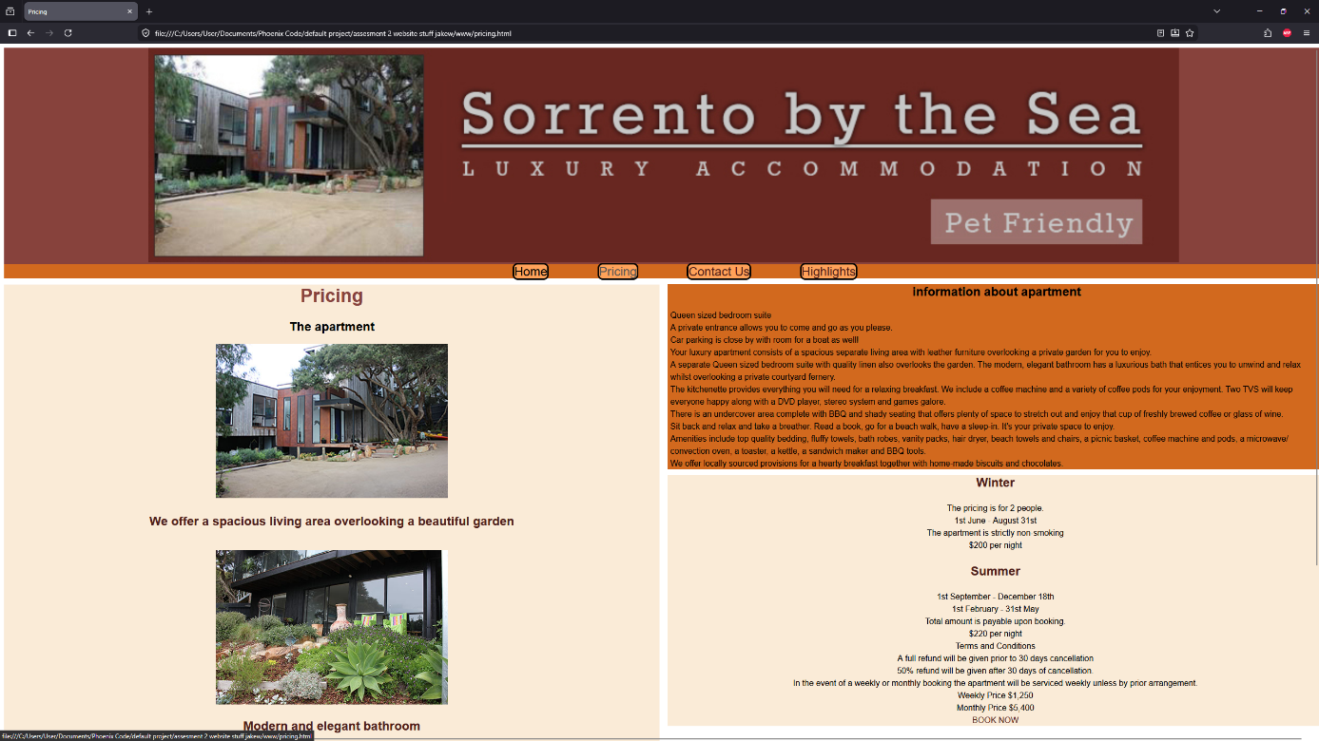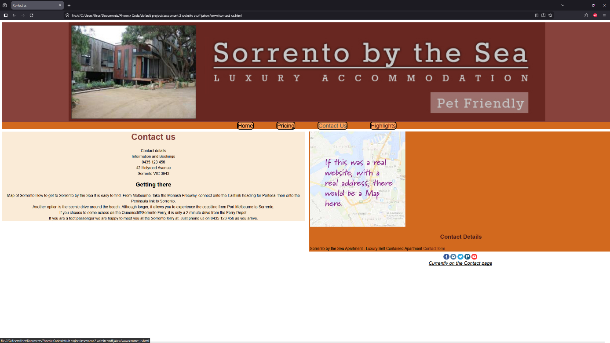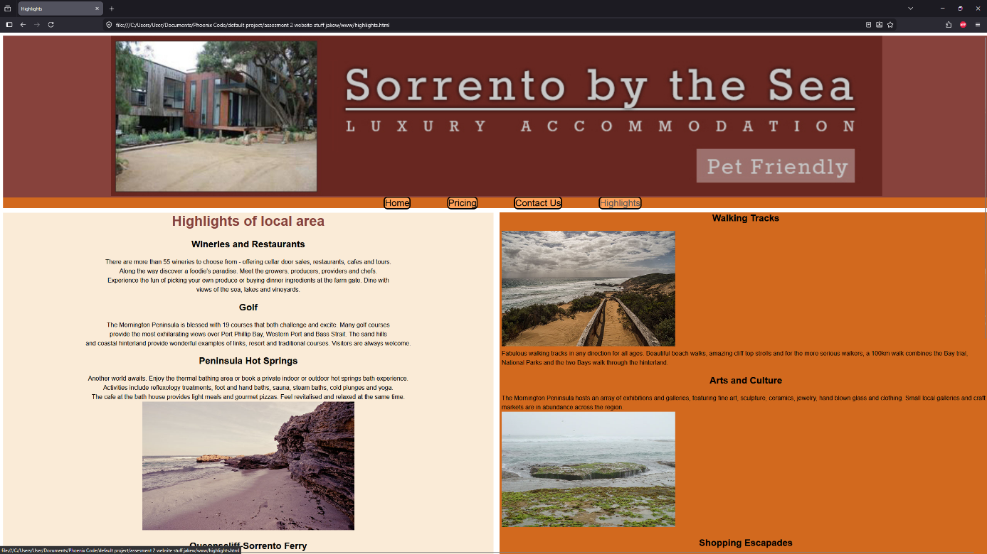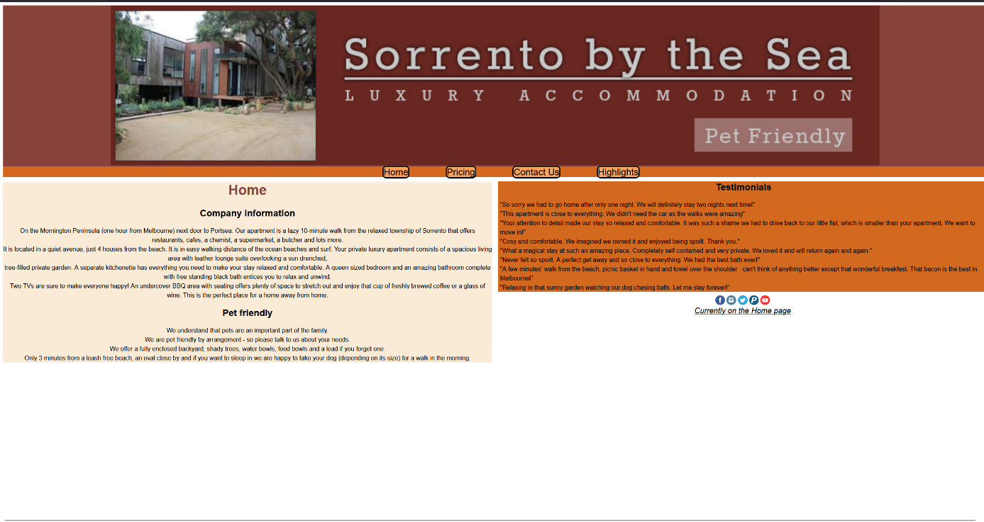
  - Validate their website to ensure it meets web standards (include screenshots).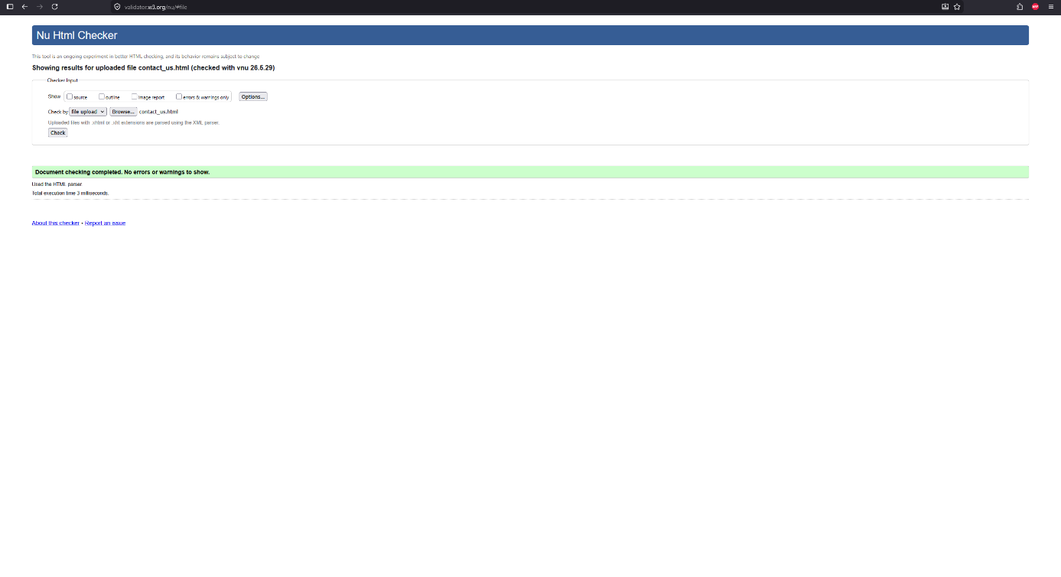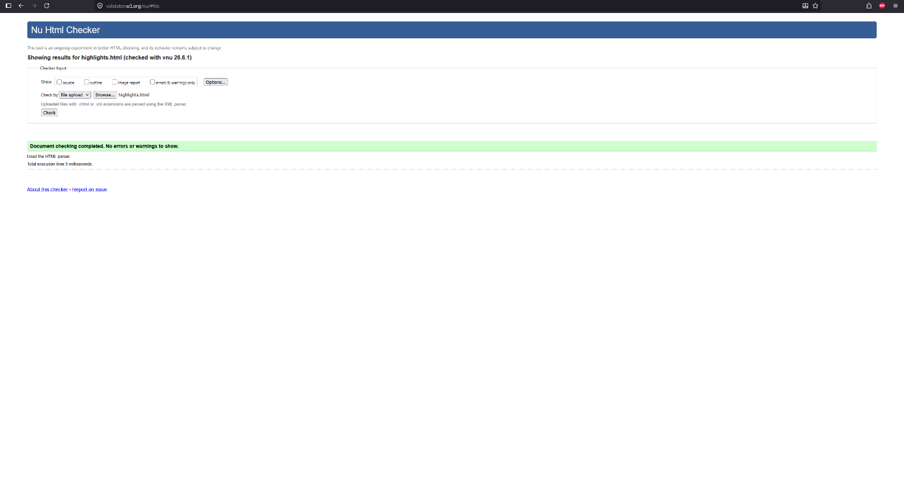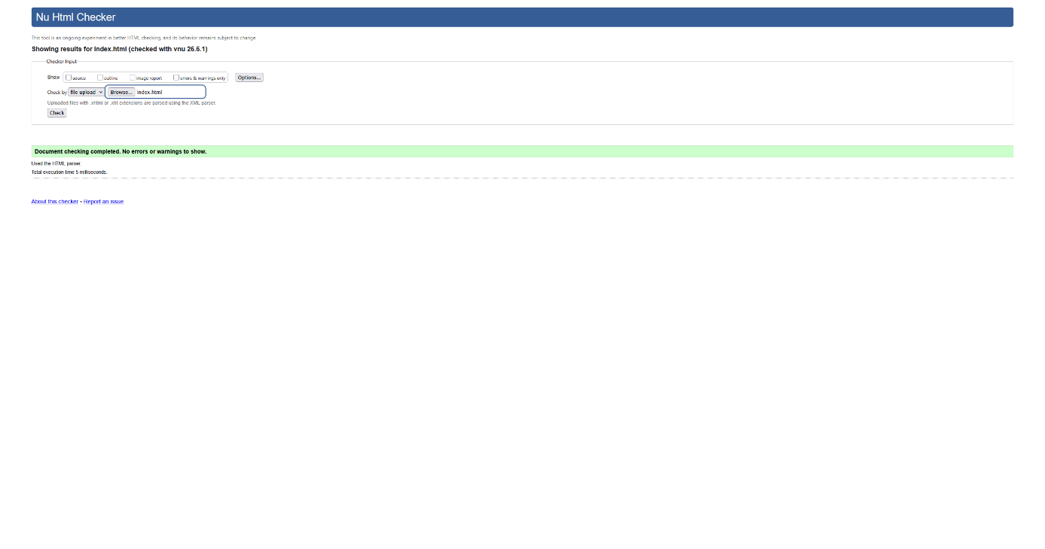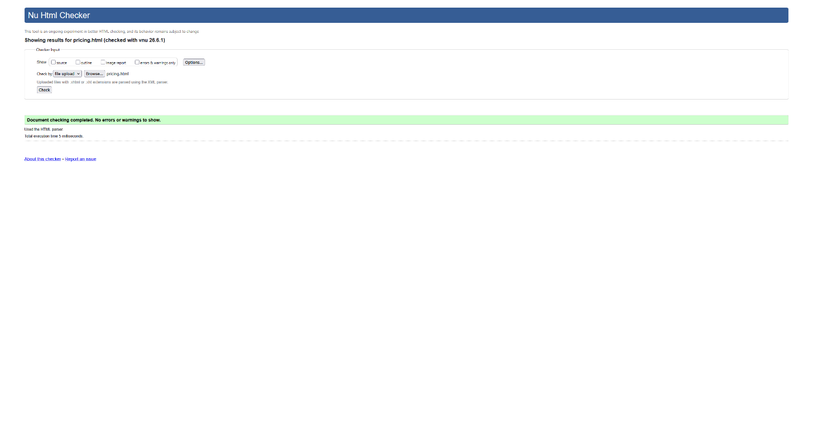
- You must correct any issues and re-test their website until it displays correctly. Discuss this re-testing, including screenshots of different versions. There were issues with the icons and the utility links being squashed however they needed to be in the footer. Also needed to fix images not having alt descriptions.
- Explain the testing process and the results, including any outstanding issues and corrective actions. I tested with w3c validator each page and found that I forgot to use the alt description in my images so I went through and fixed those other than that there were no repeating issues just minor fixes needing to be done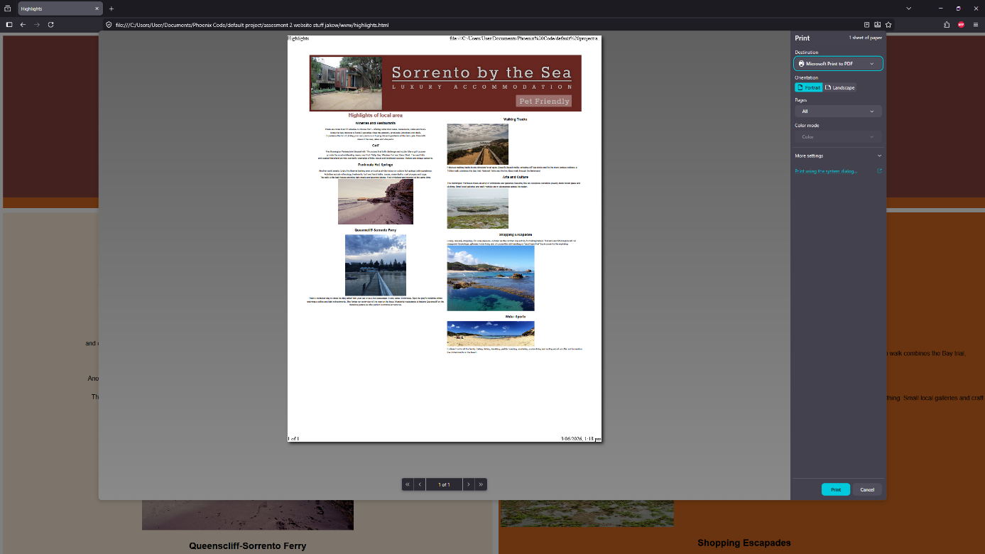

Part 5: Hand over website
To complete this part of the assessment, you will participate in a roleplay to demonstrate your ability to complete skills-based tasks to industry standards. The role play will be digitally recorded via video or voice recording and submitted as evidence.
Your demonstration will be used as part of the overall evidence requirements of the unit.
You should refer to the list of criteria provided in the Observation Checklist 2 to understand what skills you need to demonstrate in this section of the assessment. This Checklist outlines the assessment criteria your Teacher/Assessor will be marking you on.
Roleplay
Now that you have completed your website, you need to meet with the client in a role play of 10-15 minutes to demonstrate it and obtain their acceptance.
Role of the student being assessed
You will participate in a role play, playing the role of web developer. You need to include the following:
- Demonstrate finished website to client.
- Provide test results to client, explaining any outstanding issues and corrective actions.
- Correct any issues that the client brings up.
- Obtain the client’s acceptance of the finished website.
During the roleplay, you must demonstrate the following skills:
- clear and detailed verbal language to convey explicit information.

Role/s of the person/s in supporting roles
Ask a colleague, or another student to act in the supporting roles. Make sure each person has the following instructions to work from.
This role play will require the following roles:
- Client
The student needs to greet you first, and respond appropriately (e.g., shake hands). The student undertaking the role of the website developer needs to demonstrate their website to you and discuss the test results.
- Ensure that you demonstrates website, including print layout. Ask questions so they demonstrate all required features.
- There shouldn’t be any outstanding issues. If there are, they must be fixed before acceptance.
- Ask for the main headings to be slightly larger.
- All changes must be made before accepting the website.

Part 6: Correct an error
You have developed a website for another client, which displays the following error message during testing.
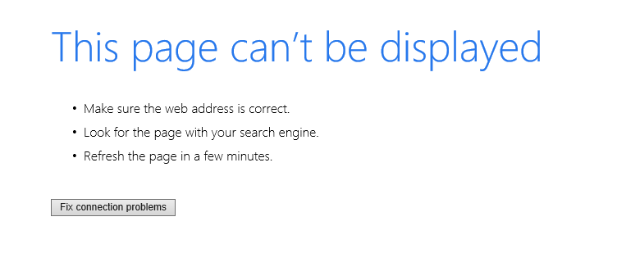
- Review the files in the website folder (ICTWEB431_AE_Pro_2of2_SR2.zip) to determine the cause of the error and make the appropriate changes to the website files.
-The html tag didn’t have any language setting.
-The CSS tag for (nav, ul, li, a) had a vertical alignment setting that was ineffective due to the display block setting.
- Menu page was called menu-page.html in folder but menu.html in code.
- The nav on the menu page was inside the header instead of below it

Assessment checklist
The assessment checklist lists the requirements for each task in this assessment as outlined in the student’s assessment instructions. The assessor will use this checklist to ensure all required tasks have been completed and submitted and provide feedback for each task.
Note that S = Satisfactory and U/S = Unsatisfactory.
Table 4 Assessment Checklist
TASK/STEP # | Instructions | S | U/S | Assessor Comments
Part 1.1 | Creates a schedule according to client’s timeframe with relevant tasks | ☐ | ☐
Part 1.2 | Builds a sitemap based on client requirements | ☐ | ☐
Part 1.3 | Builds wireframes based on client requirements | ☐ | ☐
Part 1.4 | Develops a testing plan with testing approach, test cases and testing checklist based on client requirements | ☐ | ☐ | - Functionality - checking links, entering correct and incorrect values in the form  - Compatibility - with different browsers  - Usability – nav and logo on every page, consistency, correct colours/fonts, must have two columns, must include Contact page  - Security  - Performance of the website
Part 1.5 | Selects an appropriate mark-up language based on client requirements | ☐ | ☐
Part 3.1 | Creates appropriate directory structure | ☐ | ☐
Part 3.2, 3.3, 3.4 | Creates the page structure and at least three webpages using essential basic elements, supplied content, navigation, footer, logo and current page indicator | ☐ | ☐
Part 3.5 | Uses semantically correct structural mark-up | ☐ | ☐
Part 3.6 | Styles, formats and lays out pages using CSS according to requirements | ☐ | ☐
Part 4.1 | Tests website in two browsers using test approach and test cases | ☐ | ☐
Part 4.1 | Validates website to meet web standards | ☐ | ☐
Part 4.2 | Corrects any errors | ☐ | ☐
Part 4.3 | Explains the testing, any outstanding issues and corrective actions | ☐ | ☐
Part 6.1 | Corrects website error | ☐ | ☐

Observation Checklist 1
The assessor will use this checklist while observing you completing your assessment. Read the checklist to understand what skills you need to demonstrate/ items you need to complete or submit. You must meet all the criteria.
Note that S = Satisfactory and U/S = Unsatisfactory.
Table 5 Observation Checklist
Task # | Task/Activity Performed | S | U/S | Assessor Comments  (Describe the student’s ability in demonstrating the required skills and knowledge)
Part 2 | Uses open-ended questioning and active listening, including paraphrasing and summarising | ☐ | ☐
Part 2 | Uses clear and detailed language | ☐ | ☐
Part 2.1 | Identifies work outcomes and organisational standards to be followed | ☐ | ☐
Part 2.2 | Understands own role and responsibilities | ☐ | ☐
Part 2.3 | Reviews and refines website structure – wireframes and sitemap | ☐ | ☐
Part 2.4 | Reviews and refines testing approach and test cases | ☐ | ☐

Observation Checklist 2
The assessor will use this checklist while observing you completing your assessment. Read the checklist to understand what skills you need to demonstrate/ items you need to complete or submit. You must meet all the criteria.
Note that S = Satisfactory and U/S = Unsatisfactory.
Table 6 Observation Checklist
Task # | Task/Activity Performed | S | U/S | Assessor Comments  (Describe the student’s ability in demonstrating the required skills and knowledge)
Part 5 | Uses clear and detailed language to convey explicit information | ☐ | ☐
Part 5.1 | Demonstrates website | ☐ | ☐
Part 5.2 | Provides test results and explains issues | ☐ | ☐
Part 5.3 | Corrects any issues from client | ☐ | ☐
Part 5.4 | Obtain client’s acceptance | ☐ | ☐

Assessment feedback
NOTE: This section must have the Teacher/Assessor and student signature to complete the feedback. If you are submitting through the TAFE NSW online learning platform, your Teacher/Assessor will give you feedback via the platform.

Assessment outcome
☐ Satisfactory
☐ Unsatisfactory

Assessor feedback
☐ Has the assessment declaration for this assessment event been signed and dated by the student?
☐ Are you assured that the evidence presented for assessment is the student’s own work?
☐ Was reasonable adjustment in place for this assessment event?
If yes, ensure it is detailed on the assessment document.
Comments:

Assessor name, signature and date

Student acknowledgement of assessment outcome
Would you like to make any comments about this assessment?

Student name, signature and date

